Assignment # 1 - Designing Web App using HTML/CSS/REACT

Tasks to complete:
Create a main Root folder and start page i.e. index.html which contains all the project files and folders and also the main web pages of the project.
- we have to create css folder which will have all the css files.
- Refer to below screen shot and create one html file for three different layout(follow colors as well for containers)
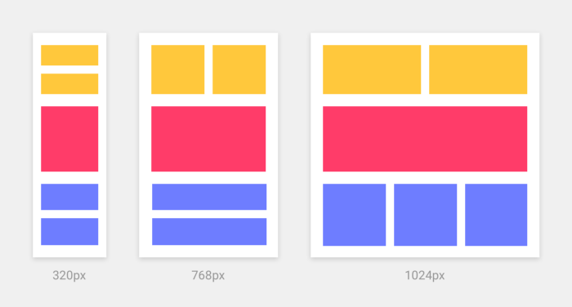

HTML Code:
<!DOCTYPE html>
<html>
<head>
<meta charset="UTF-8" />
<title>Hello World</title>

<script src="https://unpkg.com/react@17/umd/react.development.js"></script>
<script src="https://unpkg.com/react-dom@17/umd/react-dom.development.js"></script>

<!-- Don't use this in production: -->
<script src="https://unpkg.com/@babel/standalone/babel.min.js"></script>
</head>
<body>
<div id="root"></div>
<script type="text/babel">
//React Code here
</script>
<!--
Note: this page is a great way to try React but it's not suitable for production.
It slowly compiles JSX with Babel in the browser and uses a large development build of React.

Read this section for a production-ready setup with JSX:
https://reactjs.org/docs/add-react-to-a-website.html#add-jsx-to-a-project

In a larger project, you can use an integrated toolchain that includes JSX instead:
https://reactjs.org/docs/create-a-new-react-app.html

You can also use React without JSX, in which case you can remove Babel:
https://reactjs.org/docs/react-without-jsx.html
-->
</body>
</html>

Submission Steps
- Login into Github account using your crentials.
  - Click on new button
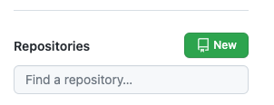
  - Click on “Import a repository”
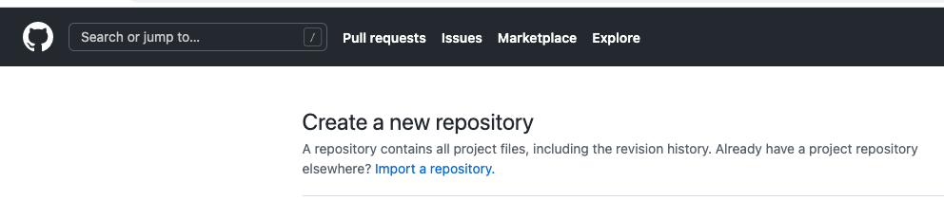
  - and Paste the URL https://github.com/the-10x-academy/React-Assignments.git
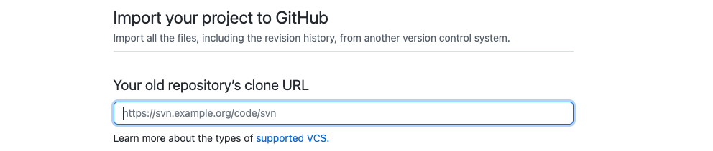
  - Please keep you Repo Name and click “Begin Import”
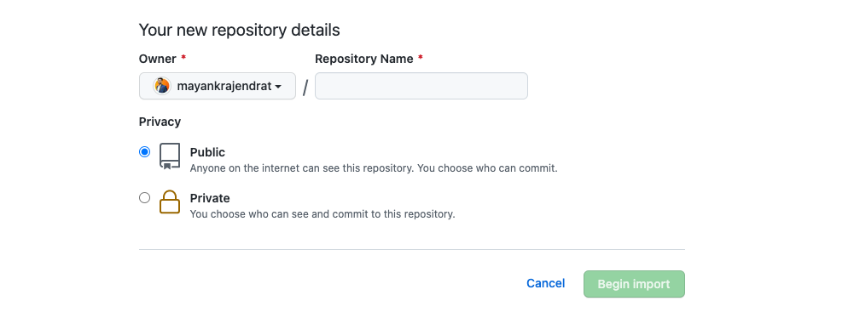

- Git Clone in Fresh and Empty folder by copy URL from Repo that create in Step 1 -

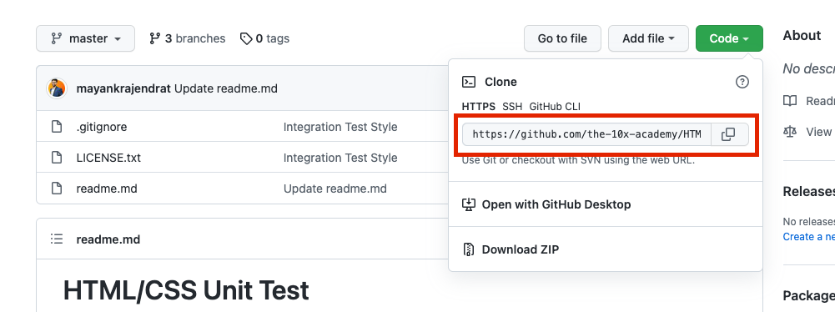

git clone 'URL'

- Open you Repo in VSCODE and in terminal type cd "Repo name”.
  - If you cloned already the repo Please follow below mentioned commands
git fetch https://github.com/the-10x-academy/React-Assignments.git master
  - git cherry-pick FETCH_HEAD

- git checkout -b "BranchName"
Note: Branch Name should be the Assignment Number for example : Assignment 1, command would be
git checkout -b Assignment-1

- Start making changes in index.html and style.css.
- Proceed with Staging using command git add . or use Vs code extension
- Git commit or use Vs code extension
- Git Push or use Vs code extension
- Create the Merge Request as mentioned in below screenshots.
  - Select the branch that checkout in step 4
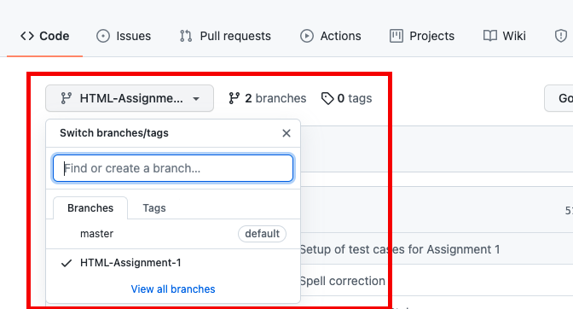

  - Click on “Pull request”
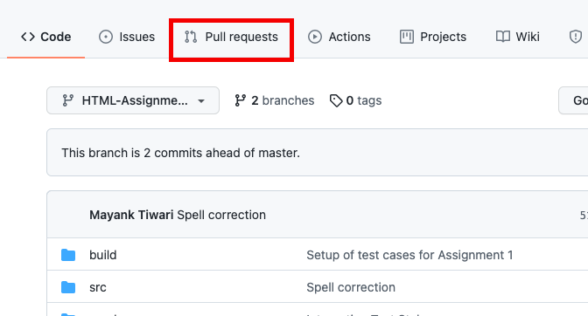
  - Click on “New Pull Request”
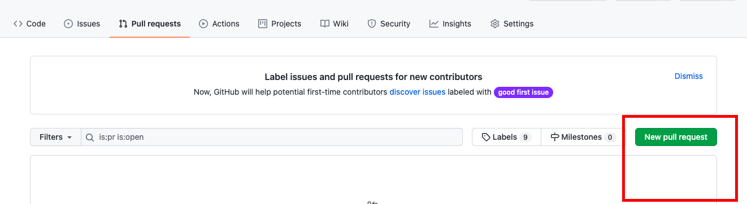

  - Select the branch that checkout in step 4
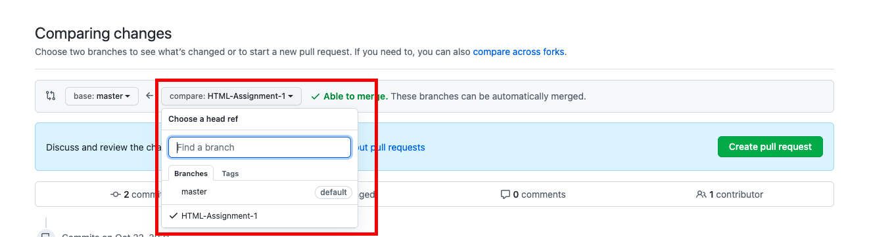
  - Create a pull request and share link of Request as your submission.
Please take screenshot of final output from your browser and keep in Pull Request description.
Share the Branch URL: https://github.com/{Username}/{Repo Name}/ pull/{Request Number}
